**Monje, Krammes, Karamyshev and Paulsen FIA ETCC Champions at Imola – Italy**

The final races of the FIA ETCC-European Touring Car Cup were held in the historical Enzo e Dino Ferrari race track in Imola, Italy over the last weekend.

The Spanish young talent, Fernando Monje, with his Seat Leon 2.0 TDI, Super 2000 ably supported by the Sunred engineering team managed to end a superb season on a winning note, by not only obtaining pole position in the qualifier on Saturday but coming away as clear winner in the two races and runaway champion ahead of Peter Rickli in the S2000 category. Monje will now focus his energy on the remaining overseas races at the World Touring Car Championship.

Also victorious at Imola were Nikolay Karamyshev from Russia, who managed to finish at the top in front of the competitive Serbian Aleksander Tosic and Italian Fabio Fabiani, in the Super production category. Meanwhile Kevin Krammes from Germany won the Super 1600 category while the promising and gifted Stian Paulsen from Norway triumphed in the Single-Make trophy narrowly beating Andreas Pfister from Germany. Mr Susumu Watanabe, representing YOKOHAMA, was in charge of the presentation of trophies at an award ceremony held shortly after the racing.

YOKOHAMA has been the exclusive tyre partner for this FIA Championship.

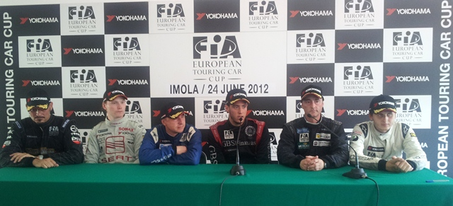

**Notes to Editors**

**YOKOHAMA is one of the leading Tyre manufacturers in the world and is Official Tyre supplier for;**  
FIA World Touring Car Championship (WTCC) – since 2006  
European Touring Car Cup (ETCC) – since 2005  
Intercontinental Rally Challenge  (IRC) – since 2007  
Scandinavian Touring Car Championship (STCC) – since 2010  
Russian Touring Car Championship (RTCC) – since 2006  
Chinese Touring Car Championship (CTCC) – since 2010  
Irish Touring Car Championship (ITCC) – new for 2012  
International Formula 3 Grand Prix Macau – since 1983   
ATS German Formula 3 – until 2005 and since 2007

FIA F2 Championship – new for 2012  
Japanese Formula 3 – since 2011

ADAC GT Masters new for 2012

GT Asia new for 2012